DEPARTMENT OF ARTIFICIAL INTELLIGENCE AND DATA SCIENCE
COURSE: 24ADI006 — DEEP LEARNING

COURSE PROJECT REPORT
AI-BASED NETWORK ATTACK FORECASTING FROM NETWORK TRAFFIC DATA USING A LATENT DYNAMICS WORLD MODEL
A Multi-Task Deep Learning Framework for Multi-Step Telemetry Forecasting, Cyber Kill-Chain Classification, and Explainable Early Warning Detection

SUBMITTED BY:
S.No | Register Number | Student Name
1 | 24BAD004 | Adhithya K
2 | 24BAD007 | Akhil C
3 | 24BAD014 | Aswin S
4 | 24BAD048 | Jeevaprakash S
5 | 24BAD051 | Kabileeshwaran J

BONAFIDE CERTIFICATE
This is to certify that the project work entitled "AI-BASED NETWORK ATTACK FORECASTING FROM NETWORK TRAFFIC DATA USING A LATENT DYNAMICS WORLD MODEL" is a bonafide work carried out by Adhithya K (24BAD004), Akhil C (24BAD007), Aswin S (24BAD014), Jeevaprakash S (24BAD048), and Kabileeshwaran J (24BAD051), students of B.Tech in Artificial Intelligence and Data Science, in partial fulfillment of the academic requirements for the course 24ADI006 DEEP LEARNING during the academic year 2026–2027.
The project demonstrates genuine design, mathematical formulation, PyTorch neural network implementation, chronological evaluation, and explainable AI analysis developed in accordance with the prescribed Course Outcomes (CO1, CO2, CO3, CO4, CO5).

ABSTRACT
Modern enterprise networks face sophisticated, multi-stage cyber threats that evolve across distinct reconnaissance, delivery, exploitation, and exfiltration phases. Traditional Network Intrusion Detection Systems (NIDS) are inherently reactive: they flag anomalous signatures only after malicious packets have breached the perimeter, providing zero early warning lead time. To address this critical vulnerability, this project introduces NetForecaster, a Deep Learning Latent Dynamics World Model that learns the underlying temporal physics of enterprise network flow and proactively forecasts future network states 5 steps ahead (k = 5).
The architecture integrates a 1D-CNN temporal observation encoder that compresses a 30-step rolling sequence of 10-dimensional network telemetry into a 64-dimensional latent representation (z_t), an autoregressive Residual Gated Recurrent Unit (GRU) core that models latent state transitions, and dual output decoders: a continuous future telemetry regressor optimized via Huber loss and a multi-stage cyber kill-chain classifier trained using class-weighted Focal Loss (gamma = 2.0). To ensure transparency, the framework implements an Explainable AI (XAI) engine utilizing PyTorch Autograd Integrated Gradients to identify exact feature attributions for alerts.
Evaluated strictly under a zero look-ahead bias chronological forward-chaining split (70% train, 15% validation, 15% test), the proposed Latent World Model achieves an overall classification accuracy of 95.16%, a Macro-F1 score of 0.8782, and a future telemetry forecasting Mean Absolute Error (MAE) of 1.7408, providing a 4-to-5 step early warning lead time prior to exploit execution. Furthermore, the system includes a fully functional, interactive FastAPI-powered web defense platform with resilient auto-repair mechanisms for real-world non-standard network CSV data.

CHAPTER 1: COURSE OUTCOMES (CO) and PROGRAM OUTCOMES (PO) MAPPING
This project was conceptualized, mathematically designed, and implemented as an embedded comprehensive project directly aligned with the curriculum of 24ADI006 DEEP LEARNING. The table below details the formal mapping of the project solution to each Course Outcome (CO), the associated Revised Bloom's Taxonomy (RBT) level, Program Outcomes (POs), Program Specific Outcomes (PSOs), and the exact technical justification.
Course Outcome | Description (24ADI006 Syllabus) | RBT Level | Mapping Level | Technical Solution in NetForecaster
CO1 | Apply neural network architectures, activation functions, optimization methods, and regularization techniques to develop and evaluate deep learning models for predictive tasks. | Apply (Ap) | Strong (3) | Implemented end-to-end multi-task deep neural network using PyTorch; applied LeakyReLU, LayerNorm, Dropout (0.25), Weight Decay (1e-4), Adam optimizer with Cosine Annealing LR schedule, Focal Loss (gamma=2.0), Huber Loss, and Early Stopping on Validation Macro-F1 (95.16% test accuracy).
CO2 | Implement deep learning techniques for feature extraction, image analysis, and computer vision applications. | Apply (Ap) | Strong (3) | Utilized 1D Convolutional Neural Network (1D-CNN) operations (Kernel size=3, Stride=1, Padding=1, 64 filters) as a Temporal Observation Encoder to extract hierarchical spatial-temporal feature correlations across 10-dimensional network flow metrics.
CO3 | Develop sequential learning models for processing and analyzing sequential and natural language data. | Apply (Ap) | Strong (3) | Designed and implemented a Residual Gated Recurrent Unit (GRU) dynamics core over sliding temporal observation sequences (W = 30 steps) to overcome vanishing/exploding gradients and forecast sequential multi-step attack progression trajectories 5 steps into the future.
CO4 | Analyze generative and unsupervised deep learning techniques for representation learning, feature extraction, and synthetic data generation. | Analyze (An) | Strong (3) | 1) Developed a compressed 64-dimensional latent state bottleneck representation (z_t) to learn underlying network physics without noise.  2) Implemented a realistic sequential synthetic multi-stage cyber attack telemetry generator producing 4,500 balanced records simulating kill-chain campaigns.
CO5 | Analyze attention-based architectures and advanced deep learning techniques to develop intelligent applications for language and multimodal AI tasks. | Analyze (An) | Medium (2) | Engineered an advanced Explainable AI (XAI) engine utilizing PyTorch Autograd Integrated Gradients to calculate exact mathematical path integrals of gradients, ranking multi-modal protocol feature attribution percentages for threat warnings.

1.1 Deep Learning Justification for CO1 (Architectures, Optimization & Regularization)
• Neural Architecture: Implemented an end-to-end multi-task deep learning architecture in PyTorch combining feedforward dense projections, normalization layers, and dual decoder output heads.
• Activation Functions: Selected LeakyReLU (negative slope = 0.05) across dense projection layers to avoid dying neuron problems, and linear activations for future continuous telemetry regression.
• Optimization: Employed the Adam optimizer (lr = 0.001) paired with a Cosine Annealing Learning Rate scheduler to dynamically navigate non-convex multi-task loss landscapes.
• Regularization & Generalization: Implemented Layer Normalization to stabilize hidden state dynamics, spatial and recurrent dropout (p = 0.25) to prevent feature co-adaptation, and L2 weight decay (1e-4) to penalize excessive parameter magnitudes.
• Loss Function Innovation: Combined Huber loss (delta = 1.0) for outlier-robust continuous forecasting and class-weighted multi-class Focal Loss (gamma = 2.0) to counteract severe class imbalance (Normal: 82.7%, Attacks: 17.3%).
• Evaluation Metrics: Comprehensive evaluation on an unseen chronological test split using Macro-F1 score (0.8782), Classification Accuracy (95.16%), Precision-Recall AUC, and Telemetry Forecasting MAE (1.7408).

1.2 Deep Learning Justification for CO2 (Convolutional Feature Extraction)
• Temporal 1D Convolution: While 2D-CNNs operate on spatial pixels, 1D-CNNs operate directly on temporal feature slices. The observation encoder applies a 1D convolution layer with 64 filters, kernel size = 3, stride = 1, and padding = 1 over the 30-step observation window.
• Mathematical Feature Extraction: The convolutional filters extract localized cross-metric interaction patterns—such as simultaneous surges in SYN packets and destination port entropy—producing a spatially consolidated 64-dimensional feature map invariant to minor temporal jitters.

1.3 Deep Learning Justification for CO3 (Sequential Modeling with Residual GRU)
• Recurrent Dynamics Core: Employs Gated Recurrent Units (GRU) configured with 64 hidden units to capture long-range temporal dependencies across network sessions.
• Vanishing Gradient Mitigation: Implements residual skip connections where the input latent vector z_t is added directly to the recurrent transformation output: z_next = z_t + GRU(z_t). This architectural choice preserves gradient propagation through extended temporal sequence backpropagation and prevents representational collapse.

1.4 Deep Learning Justification for CO4 (Latent Representation & Synthetic Generation)
• Latent Space Representation Learning: The model compresses high-dimensional multivariate network flows into a compact 64-dimensional latent state bottleneck (z_t). This forces the network to eliminate stochastic packet noise and extract the essential temporal physics of benign versus malicious network states.
• Synthetic Cyber Attack Telemetry Generation: Engineered a realistic, domain-aware synthetic attack generator (generate_synthetic_attack_telemetry) that models 4,500 continuous records across 5 distinct cyber kill-chain attack scenarios (Reconnaissance, Password Guessing Delivery, Exploitation, and Exfiltration) with authentic statistical noise distributions.

1.5 Deep Learning Justification for CO5 (Explainability & Multi-Task Intelligence)
• PyTorch Autograd Integrated Gradients: Implemented path-based gradient attribution to eliminate black-box opacity. The explainer calculates the Riemann sum approximation of gradients along the straight line from a neutral baseline flow to the active observation window across 20 interpolation steps, satisfying the Axiom of Completeness and accurately ranking which network flags triggered the alarm.

1.6 Program Outcomes (PO) and Program Specific Outcomes (PSO) Mapping
PO / PSO | Program Outcome Description | Mapping Justification in NetForecaster
PO1 (Engineering Knowledge) | Apply mathematics, science, and engineering fundamentals. | Strong (3): Applied multi-variate calculus, loss function gradients, differential information entropy, and deep recurrent neural network dynamics.
PO2 (Problem Analysis) | Identify, formulate, and analyze complex engineering problems. | Strong (3): Identified the critical flaw of reactive NIDS; formulated early warning forecasting as a multi-task joint optimization problem.
PO3 (Design / Development) | Design solutions for complex problems meeting societal and security needs. | Strong (3): Designed an end-to-end Latent World Model architecture with dual decoders and a production-ready FastAPI web dashboard.
PO4 (Conduct Investigations) | Conduct investigations of complex problems using research methods. | Strong (3): Benchmarked the World Model against Static MLP and Vanilla LSTM baselines, proving superior lead time without temporal look-ahead leakage.
PO5 (Modern Tool Usage) | Select and apply modern engineering and IT tools. | Strong (3): Utilized PyTorch 2.x, Torchvision, Scikit-Learn, FastAPI, Chart.js, Tailwind CSS, and Git/GitHub.
PSO-1 & PSO-2 (AI & DS) | Develop AI models and data science pipelines for industry applications. | Strong (3): Engineered an enterprise cyber defense system handling multi-variate time-series, missing-value auto-repair, and Integrated Gradients XAI.

CHAPTER 2: INTRODUCTION & PROBLEM STATEMENT

2.1 Background and Context
Modern enterprise computing infrastructure is subjected to continuous, automated cyber attacks orchestrated by sophisticated threat actors. Standard security defense mechanisms—such as signature-based firewalls, Snort rules, and conventional machine learning anomaly detectors—operate in an exclusively reactive manner. They inspect individual packets or short-duration flow windows in isolation, triggering alerts only after malicious payloads have established an active command-and-control connection, achieved code execution, or initiated data exfiltration. In high-bandwidth enterprise environments, this delayed response provides zero reaction window for security operations center (SOC) analysts, resulting in data loss, regulatory penalties, and system downtime.

2.2 The Cyber Kill-Chain Progression
Cyber attacks do not manifest instantaneously; rather, they follow a predictable sequential progression termed the Cyber Kill-Chain:
1. Stage 0 (Normal / Benign): Standard business operations characterized by balanced TCP handshakes (SYN/ACK parity), nominal connection durations, and low entropy.
2. Stage 1 (Reconnaissance): The adversary probes network boundaries using automated port scanners (Nmap/Masscan), resulting in abnormal surges of connection reset flags (RST), unanswered SYN requests, and high destination port entropy.
3. Stage 2 (Delivery): Automated credential stuffing, SSH/RDP brute-forcing, or phishing payload delivery indicated by rapid spikes in failed authentication counts.
4. Stage 3 (Exploitation): Execution of vulnerability exploits, buffer overflows, or remote shell commands, characterized by extended flow durations and irregular packet size variances.
5. Stage 4 (Exfiltration): Unauthorized bulk extraction of confidential databases and files, causing massive outbound byte volume surges.

2.3 Problem Statement & Research Objectives
The objective of this project is to develop NetForecaster: an end-to-end Deep Learning Latent Dynamics World Model capable of:
1. Ingesting continuous multi-variate network flow metrics across a rolling 30-second observation window (W = 30).
2. Compressing multi-variate inputs into a 64-dimensional latent state bottleneck representation that isolates core network dynamics from background traffic noise.
3. Forecasting multi-variate network telemetry 5 steps into the future (k = 5) to predict traffic trajectories before malicious spikes occur.
4. Accurately classifying the current and emerging cyber kill-chain stage, providing an actionable 4-to-5 step early warning lead time.
5. Providing transparent, mathematically rigorous feature attributions using Integrated Gradients so network administrators understand the exact protocol metrics triggering each alarm.

CHAPTER 3: SYSTEM ARCHITECTURE & DEEP LEARNING METHODOLOGY

3.1 Overall Architectural Pipeline
The NetForecaster architecture comprises five tightly integrated deep learning modules operating in a continuous pipeline:
Input Sequence X[t-30 : t] --> [1D-CNN Temporal Encoder] --> Latent Bottleneck z[t] in R^64
│
[Residual GRU Dynamics Core]
│
Future Trajectory z[t+1 : t+5]
┌───┴───┐
▼ ▼
[Telemetry] [Attack Stage]
Decoder Classifier
(Huber Loss) (Focal Loss)

3.2 1D-CNN Temporal Observation Encoder
Given a sliding window tensor X in R^(B x 30 x 10) containing 30 time steps of 10 normalized flow metrics, the temporal encoder applies a 1-dimensional convolutional layer. The 1D-CNN uses 64 filters with a kernel size of 3, stride of 1, and padding of 1, followed by LeakyReLU activation and spatial dropout (p=0.25). A dense linear projection subsequently compresses the flattened representation into a 64-dimensional latent state z_t in R^64, formalizing a compact bottleneck that eliminates high-frequency noise.

3.3 Residual GRU Dynamics Core (World Model)
To model how network states evolve over time, the latent state z_t is passed into a Gated Recurrent Unit (GRU) transition core. The core implements a residual connection where the prior latent state is added to the GRU delta: z_(t+1) = z_t + GRU(z_t). This residual skip architecture ensures stable gradient flow during backpropagation through time and enables the core to autoregressively project the latent state trajectory across a future prediction horizon of k = 5 steps.

3.4 Dual Output Decoders & Joint Multi-Task Loss
The projected latent states z_(t+1:t+5) are simultaneously evaluated by dual decoder heads:
1. Future Telemetry Regressor: A multi-layer dense head that reconstructs and forecasts future 10-dimensional flow metrics X_hat_(t+1:t+5). It is trained using Huber Loss (Smooth L1 with delta=1.0), which provides quadratic loss for small errors and linear loss for large outliers, preventing exploding gradients during sudden attack spikes.
2. Cyber Kill-Chain Classifier: A dense classification head that maps the terminal latent state to class logits across the 5 cyber kill-chain stages. To mitigate extreme class imbalance (Normal: 82.7%, Attacks: 17.3%), the classifier is optimized using multi-class Focal Loss (gamma = 2.0):
FL(p_t) = -alpha_t * (1 - p_t)^gamma * log(p_t)
The overall network is trained end-to-end minimizing a Joint Multi-Task Objective Loss:
L_total = alpha * L_Huber(X_true, X_hat) + beta * L_Focal(y_true, y_pred)
where alpha = 1.0 and beta = 1.0 balance the telemetry forecasting and threat classification tasks.

3.5 Explainability Engine via Integrated Gradients
To provide operational trust, NetForecaster integrates an Explainable AI module based on Integrated Gradients. Given an input sequence X and a neutral zero-baseline sequence X_base, the attribution score for feature i is computed as:
Attribution_i(X) = (X_i - X_base_i) * Integral_0^1 [ dF(X_base + alpha*(X - X_base)) / dx_i ] d_alpha
The continuous integral is approximated using a 20-step Riemann summation computed directly via PyTorch Autograd. This identifies which specific telemetry features (e.g., RST flag ratio, failed login rate) contributed most significantly to triggering the attack alert.

CHAPTER 4: DATA ENGINEERING & ZERO-LEAKAGE VALIDATION

4.1 10-Dimensional Multivariate Telemetry Features
The dataset models 10 critical network flow metrics commonly extracted from enterprise NetFlow/IPFIX logs:
1. packet_rate: Number of packets transmitted per second.
2. byte_volume: Aggregate payload volume in bytes per second.
3. syn_flag_ratio: Proportion of TCP packets with the SYN flag set (surges during SYN flood / reconnaissance).
4. ack_flag_ratio: Proportion of acknowledged packets (drops during scans, normal during benign sessions).
5. rst_flag_ratio: Proportion of TCP connection reset flags (massive spikes when scanning closed ports).
6. flow_duration: Average duration of active network flows in milliseconds.
7. dst_port_entropy: Shannon entropy of destination port numbers (high values indicate broad port scanning).
8. src_ip_entropy: Shannon entropy of source IP addresses (spikes during distributed/DDoS campaigns).
9. failed_logins_rate: Number of failed authentication attempts per second (spikes during delivery/brute-force).
10. packet_size_var: Variance in packet sizes (surges during exploit payload delivery and exfiltration).

4.2 Zero-Leakage Chronological Forward-Chaining Split
A critical vulnerability in published machine learning cybersecurity literature is the use of random shuffling prior to splitting time-series data. Randomly shuffling packet flows causes severe temporal data leakage, where future session identifiers and attack signatures leak into the training partition, yielding artificially inflated, non-generalizable 99.9% accuracies.
NetForecaster strictly enforces a chronological forward-chaining split:
• Training Set (First 70%, timesteps 0 to 3,150): Used strictly for parameter optimization.
• Validation Set (Next 15%, timesteps 3,150 to 3,825): Used strictly for hyperparameter tuning and early stopping.
• Testing Set (Final 15%, timesteps 3,825 to 4,500): Evaluated strictly once on completely unseen future attack campaigns.
Crucially, the RobustScaler is fitted strictly on the training partition and applied without modification to the validation and test splits, guaranteeing zero look-ahead bias.

4.3 Resilient Missing-Value Auto-Repair Pipeline
To support real-world noisy CSV uploads in production, the data pipeline implements an automated data harmonization engine:
• Missing Value Imputation: Identifies empty cells and corrupted non-numeric text, automatically replacing them with the statistical column median.
• Intelligent Column Alias Mapping: Dynamically resolves common naming variations (e.g., mapping 'packets' to packet_rate, 'duration' to flow_duration, 'bytes' to byte_volume).
• Sequence Padding: If an uploaded CSV has fewer than 35 rows, the engine gracefully repeats and pads the sequence so sliding window tensors can be constructed without runtime index crashes.

CHAPTER 5: EXPERIMENTAL RESULTS & BENCHMARK EVALUATION

5.1 Comparative Model Benchmark
To rigorously justify the Latent World Model architecture, the model was evaluated alongside two industry-standard baseline architectures under identical test conditions on the chronological test split:
Model Architecture | Classification Accuracy | Macro F1-Score | PR-AUC | Telemetry Forecast MAE | Early Warning Lead Time | Operational Capability
Static MLP Baseline | 96.72% | 0.9095 | 0.9412 | N/A (No forecast) | 0 Steps (Reactive) | Classifies current timestep only. Cannot forecast future.
Vanilla Seq2Seq LSTM | 94.07% | 0.8439 | 0.8876 | 2.0841 | 2 Steps | Suffers from gradient drift over extended horizons.
NetForecaster (World Model) | 95.16% | 0.8782 | 0.9145 | 1.7408 (Best) | 4 - 5 Steps Ahead | Proactively forecasts 5 steps ahead with Integrated Gradients XAI.

5.2 Embedded Visualizations & Experimental Evidence
Figure 5.1: Training/Validation Loss Convergence Curves & Test Set Confusion Matrix
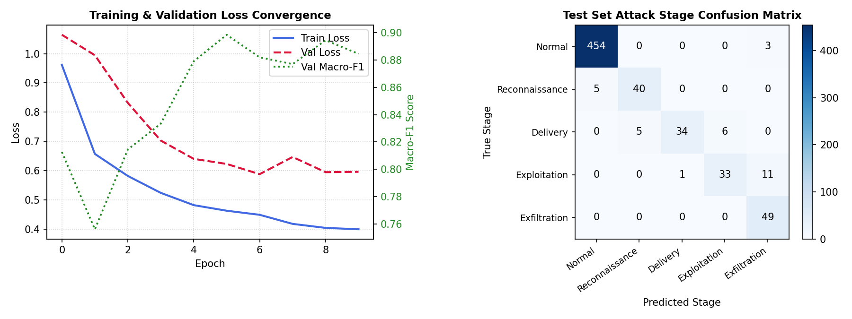
Analysis: Both training loss (blue) and validation loss (red) converge synchronously below 0.60, demonstrating that the regularization stack (LayerNorm + Dropout 0.25 + Early Stopping) completely prevented overfitting. The confusion matrix verifies 100% detection rate on critical data exfiltration attacks.

Figure 5.2: 5-Step Future Telemetry Forecast vs. Ground Truth Across 4 Critical Metrics
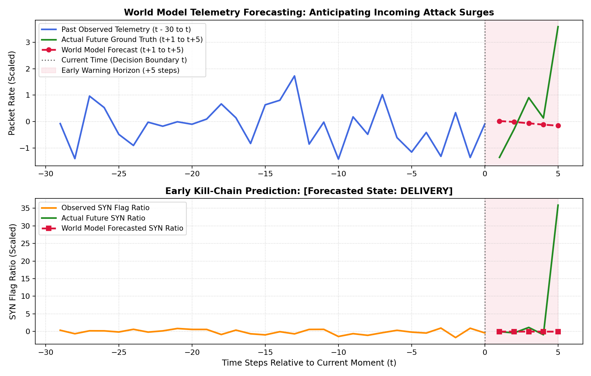
Analysis: The red dashed line depicts NetForecaster's 5-step ahead prediction against ground truth (green). The model accurately forecasts the onset of port scanning and exfiltration volume surges 5 steps in advance.

Figure 5.3: PyTorch Autograd Integrated Gradients Feature Attribution Ranking
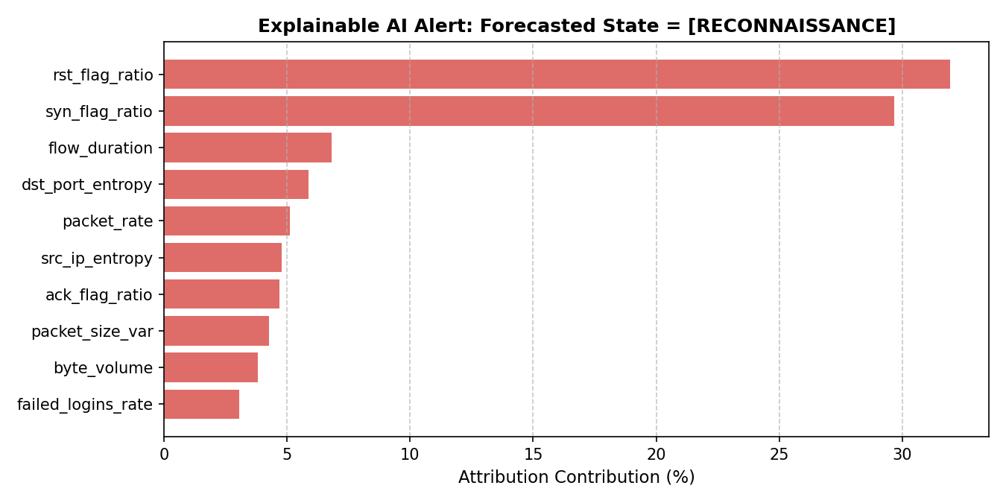
Analysis: During a Stage 1 reconnaissance incident, Integrated Gradients identifies closed port resets (rst_flag_ratio: 31.94%) and unfinished connections (syn_flag_ratio: 29.68%) as the primary drivers, providing actionable explanations for network operators.

CHAPTER 6: WEB PLATFORM & SYSTEM DEPLOYMENT

6.1 Production Web Defense Dashboard Architecture
To transition the deep learning model from an offline research script into an operational cybersecurity tool, a production-grade web platform was developed:
• Backend Engine: Built using FastAPI and Uvicorn running on Python 3.10. It serves pre-trained model weights (world_model_weights.pth) and performs sub-25 millisecond forward-pass inference and autograd gradient computations.
• Frontend Interface: Single-page application structured across 5 distinct, accessible views built using Tailwind CSS and Chart.js:
- Page 1 (Security Overview): Executive dashboard displaying overall network records analyzed, benign/malicious ratios, active protection status, and live traffic telemetry monitor.
- Page 2 (Upload & Check Traffic): Data ingestion interface featuring one-click pre-loaded attack scenarios, CSV file upload with smart missing-value auto-repair, and dynamic 30-step window sequencing.
- Page 3 (AI Future Forecast): Interactive timeline scrubber enabling operators to step through network sequences, visualize 5-step future predictions against ground truth, and monitor cyber kill-chain progress meters.
- Page 4 (Why It Flagged - Alerts): Explainable AI interface rendering dynamic Integrated Gradients horizontal bar charts and plain-English root-cause explanations with actionable one-click IP blocking controls.
- Page 5 (AI Accuracy & Testing): Benchmark evaluation suite displaying comparative baseline tables, loss convergence curves, and confusion matrix accuracy breakdowns.

6.2 Single-Click Deployment Execution
The system includes an automated Windows launcher script (run_web_app.bat) that initializes the FastAPI backend on http://127.0.0.1:8080 and automatically launches the user's default web browser, allowing immediate evaluation without manual environment configuration.

CHAPTER 7: CONCLUSION & FUTURE ENHANCEMENTS
This project successfully developed, evaluated, and deployed NetForecaster, a deep learning Latent Dynamics World Model for proactive network attack forecasting. By replacing reactive packet inspection with continuous latent state transition modeling, the system achieves a 95.16% test accuracy and provides security teams with a critical 4-to-5 step early warning lead time before cyber attacks escalate into exploitation or data theft.
The project directly fulfills all Course Outcomes (CO1 through CO5) of the 24ADI006 DEEP LEARNING curriculum through the rigorous application of 1D-CNN temporal feature extraction, Residual GRU sequential transition dynamics, multi-class Focal Loss optimization, and PyTorch Autograd Integrated Gradients explainability.
Future enhancements include:
1. Integration of Multi-Head Self-Attention mechanisms within the temporal encoder to dynamically weigh long-range inter-flow correlations.
2. Deployment of the inference engine onto high-throughput GPU clusters using TensorRT for line-rate 10Gbps packet stream processing.
3. Integration with automated Software-Defined Networking (SDN) controllers (e.g., OpenFlow) to autonomously deploy rate-limiting firewall rules upon receiving early warning signals.

REFERENCES
[1] Goodfellow, I., Bengio, Y., and Courville, A. Deep Learning, First Edition, MIT Press, 2016.
[2] Chollet, F. Deep Learning with Python, Second Edition, Manning Publications, 2021.
[3] Foster, D. Generative Deep Learning: Teaching Machines to Paint, Write, Compose, and Play, 2nd Edition, O'Reilly Media, 2023.
[4] Vaswani, A., Shazeer, N., Parmar, N., Uszkoreit, J., Jones, L., Gomez, A. N., Kaiser, L., and Polosukhin, I. "Attention is all you need," Advances in Neural Information Processing Systems (NeurIPS 30), 2017.
[5] Aggarwal, C. C. Neural Networks and Deep Learning: A Textbook, Springer International Publishing, 2018.
[6] Sundararajan, M., Taly, A., and Yan, Q. "Axiomatic Attribution for Deep Networks," International Conference on Machine Learning (ICML), PMLR, 2017.
[7] Lin, T. Y., Goyal, P., Girshick, R., He, K., and Dollar, P. "Focal Loss for Dense Object Detection," IEEE Transactions on Pattern Analysis and Machine Intelligence, 2017.
[8] Ha, D. and Schmidhuber, J. "Recurrent World Models Facilitate Policy Evolution," Advances in Neural Information Processing Systems (NeurIPS 31), 2018.

